**Criterion B: Design**

Design of the Solution

The web application has 3 basic modules:

* User Management
* Patient Management
* Picture Management

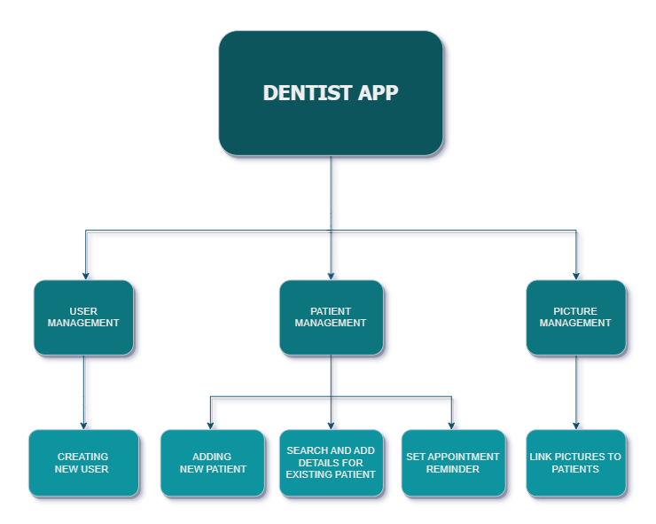

**Module 1: User Management**

Functionality 1: Creating New User

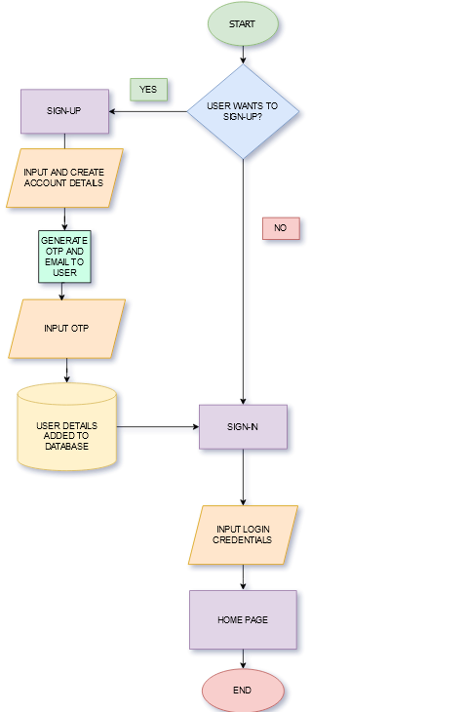

**Module 2: Patient Management**

Functionality 1: Adding New Patient

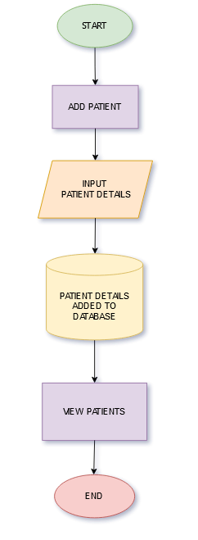

Functionality 2: Search and Add Details for Existing Patient

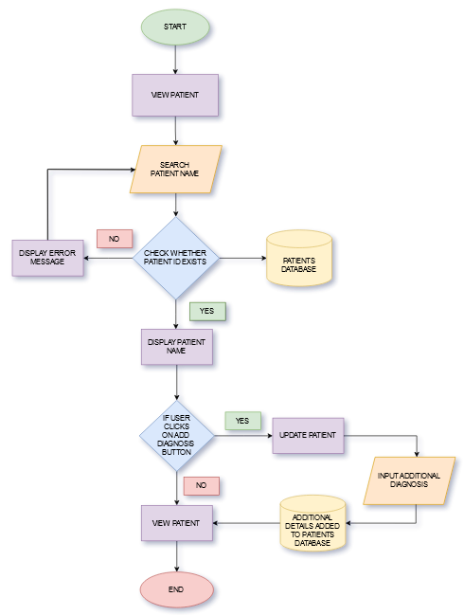

Functionality 3: Set Appointment Reminder

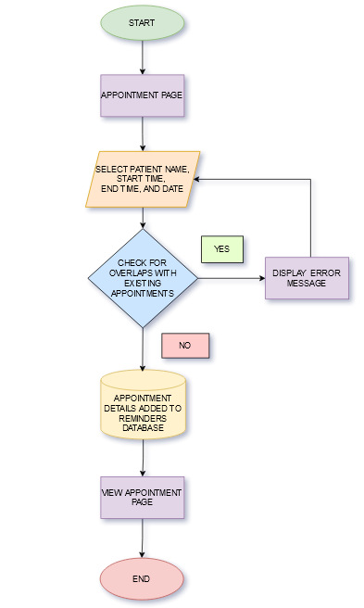

**Module 3: Picture Management**

Functionality 1: Link Picture to Patients

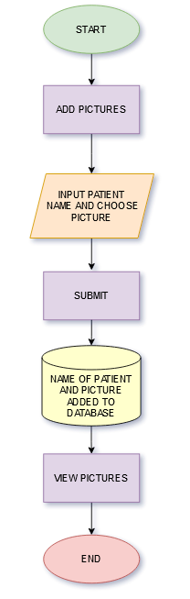

**Table Design (Database)**

To store the data for this application, I have chosen to use a MySQL Database for convenient storing and access of data.

Table 1 - Users

|  |  |  |  |
| --- | --- | --- | --- |
| FIELD NAME | DATA TYPE | CHAR LIMIT | DESCRIPTION |
| id | Integer | - | Count of the number of Users |
| username | String | 16 | Username of the User |
| email | String | 120 | Email of the User |
| password | String | 60 | Password for the account |

Table 2 – Patient

|  |  |  |  |
| --- | --- | --- | --- |
| FIELD NAME | DATA TYPE | CHAR LIMIT | DESCRIPTION |
| id | Integer | - | Count of the number of Patients |
| user_id | Integer | - | Foreign key, referencing the user associated with the patient. |
| name | String | 16 | Name of the Patient |
| age | Integer | - | Age of the Patient |
| gender | String | 16 | Gender of the Patient |
| diagnosis | TEXT | - | Diagnosis of the Patient’s problem |

Table 3 - Picture

|  |  |  |  |
| --- | --- | --- | --- |
| FIELD NAME | DATA TYPE | CHAR LIMIT | DESCRIPTION |
| id | Integer | - | Primary key, unique identifier for the picture. |
| patient_id | Integer | - | Foreign key referencing the patient associated with the picture. |
| image_data | LargeBinary | Unlimited | Binary data representing the image |
| image_type | String | 10 | file extension/type of the image |

Table 4 – Appointment

|  |  |  |  |
| --- | --- | --- | --- |
| FIELD NAME | DATA TYPE | CHAR LIMIT | DESCRIPTION |
| id | Integer | - | Primary key, unique identifier for the appointment. |
| patient_id | Integer | - | Foreign key referencing the patient associated with the appointment. |
| date | Date | - | Date of the appointment. |
| start_time | Time | - | Start time of the appointment. |
| end_time | Time | - | End time of the appointment. |

**Screen Design**

Signup page

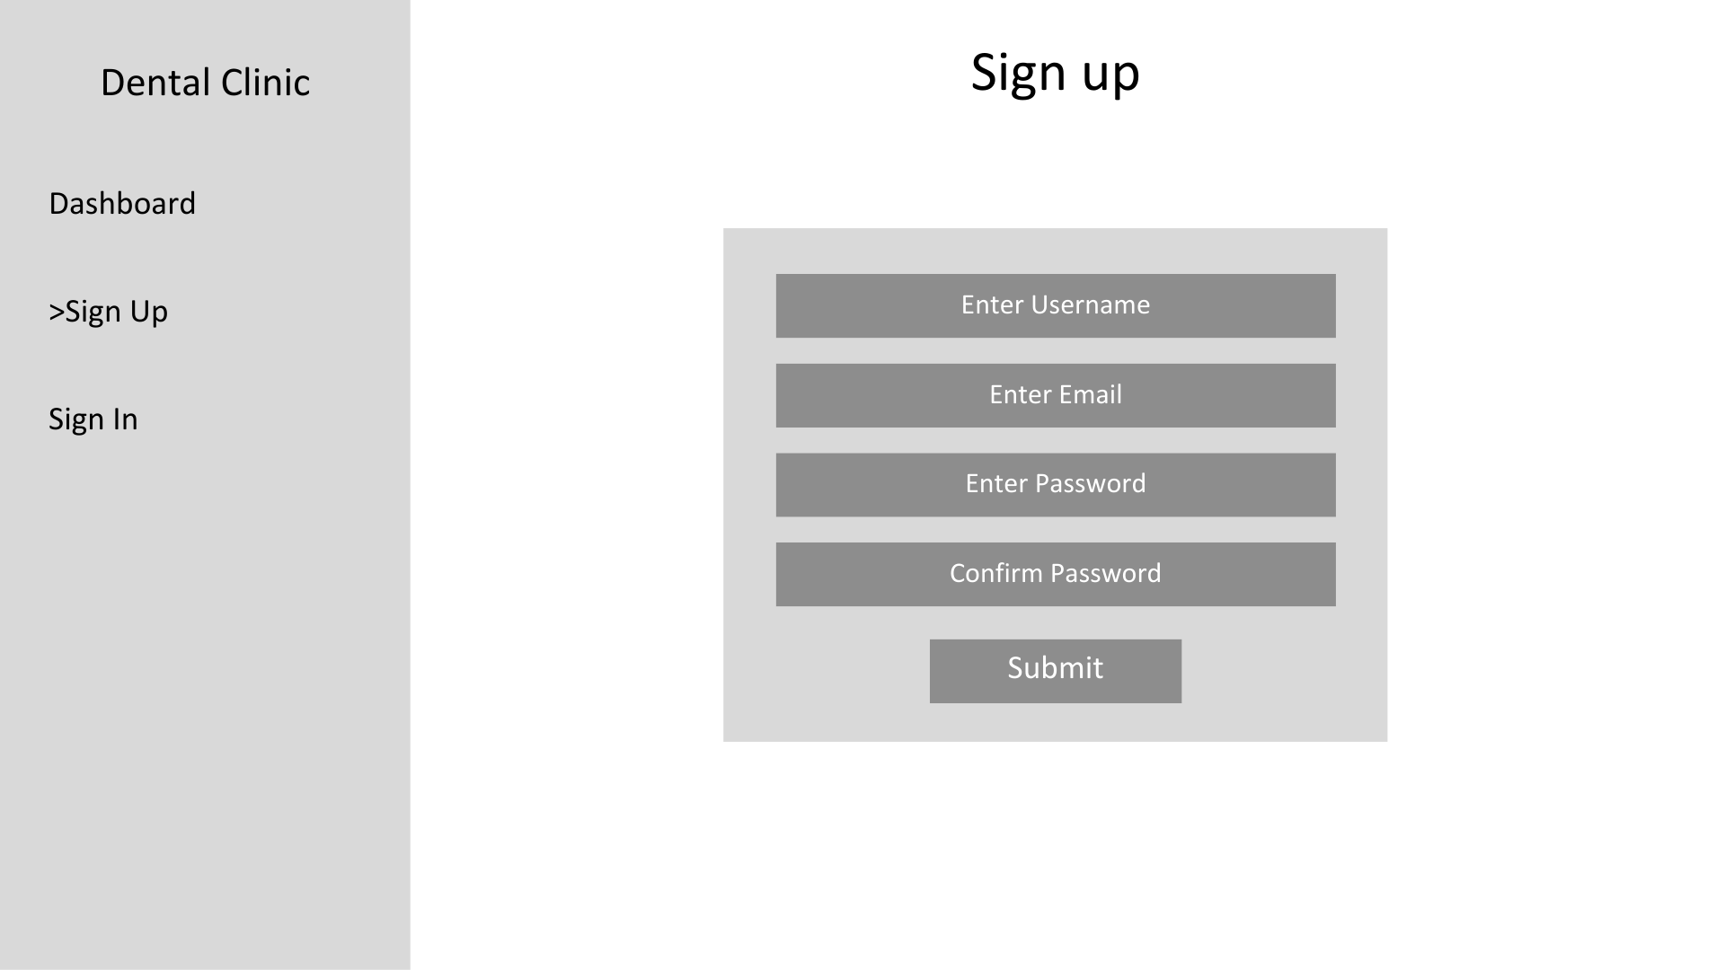

Signin page

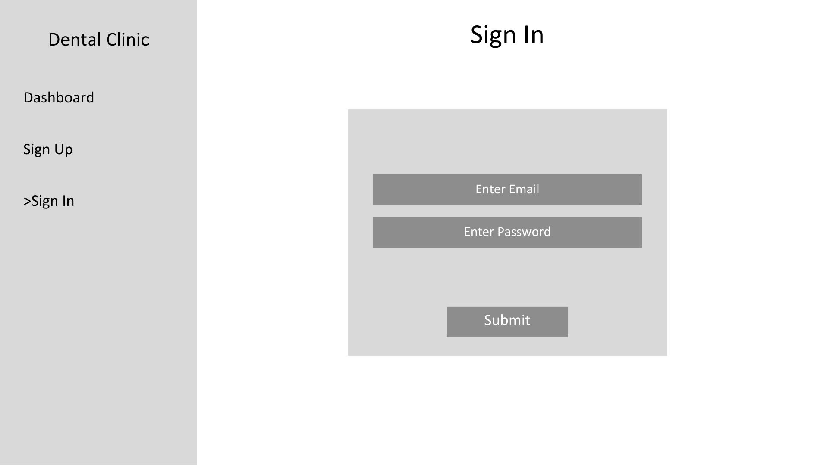

Dashboard

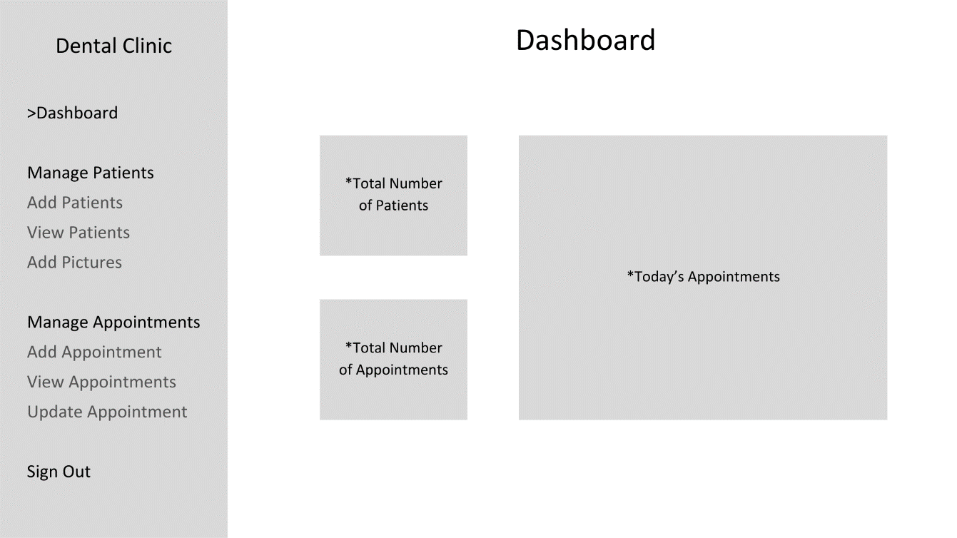

Add Patient page

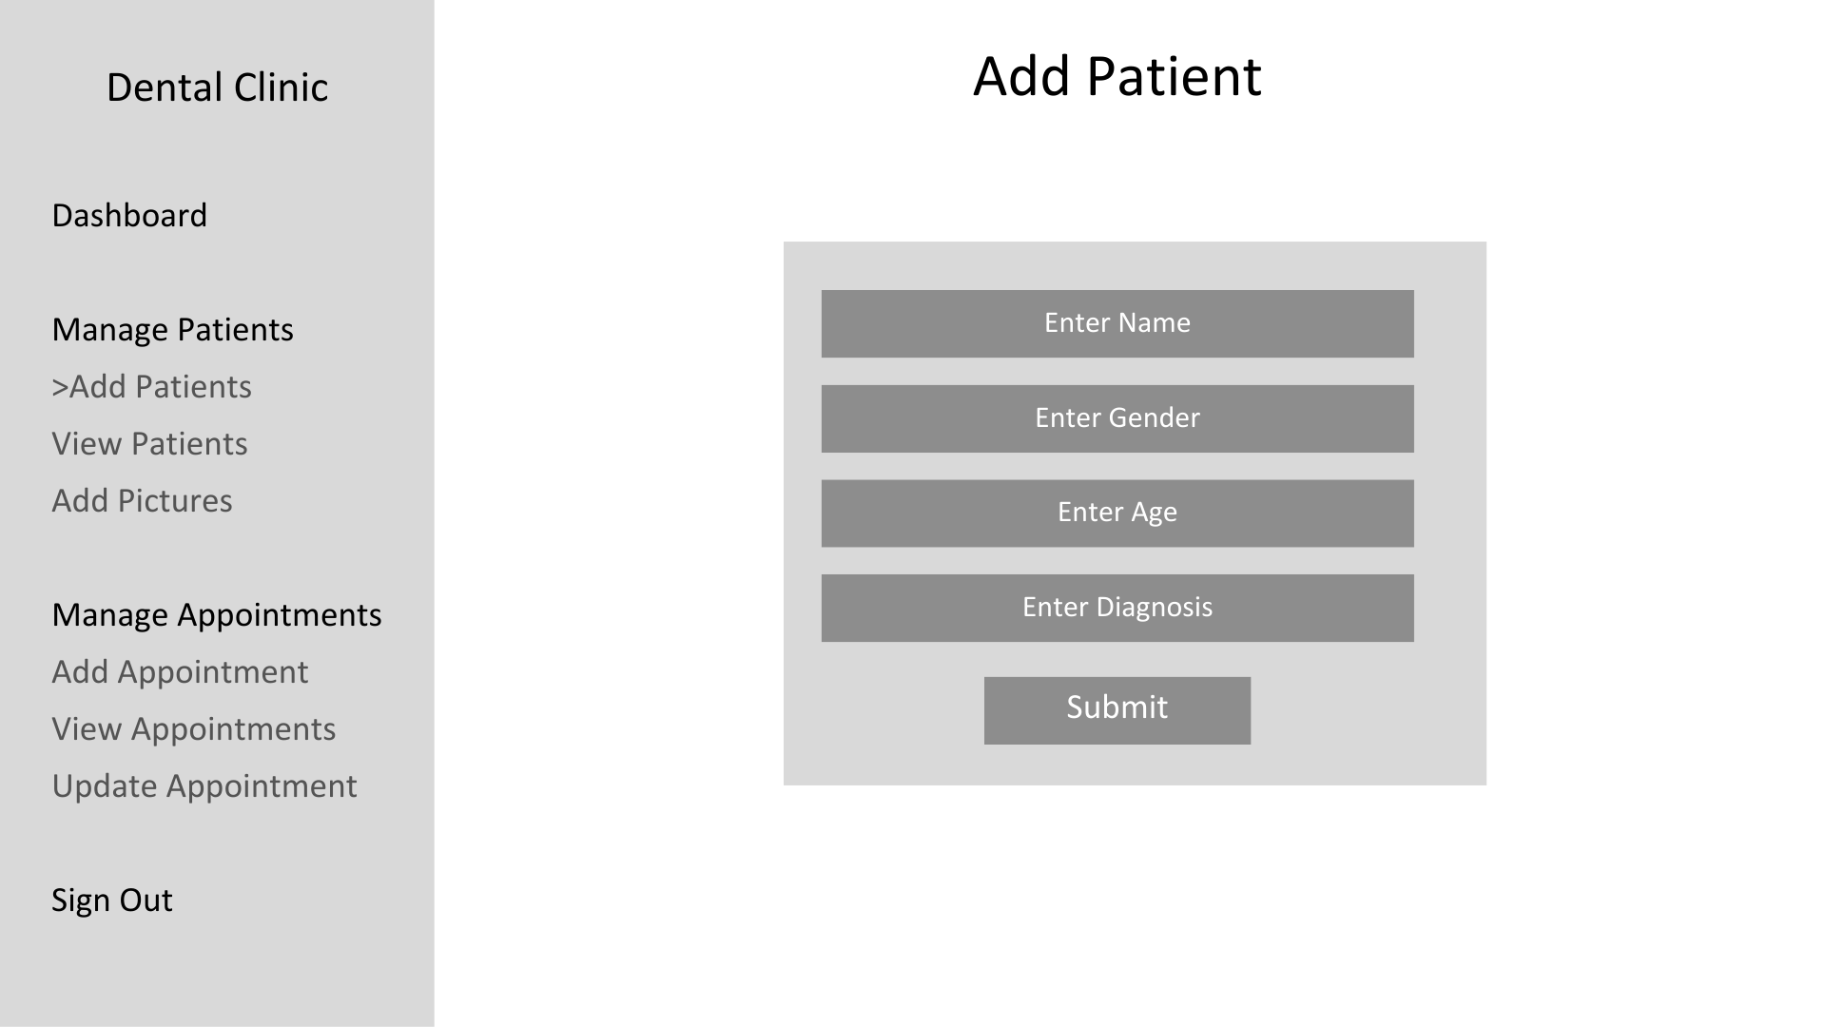

Add Picture Page

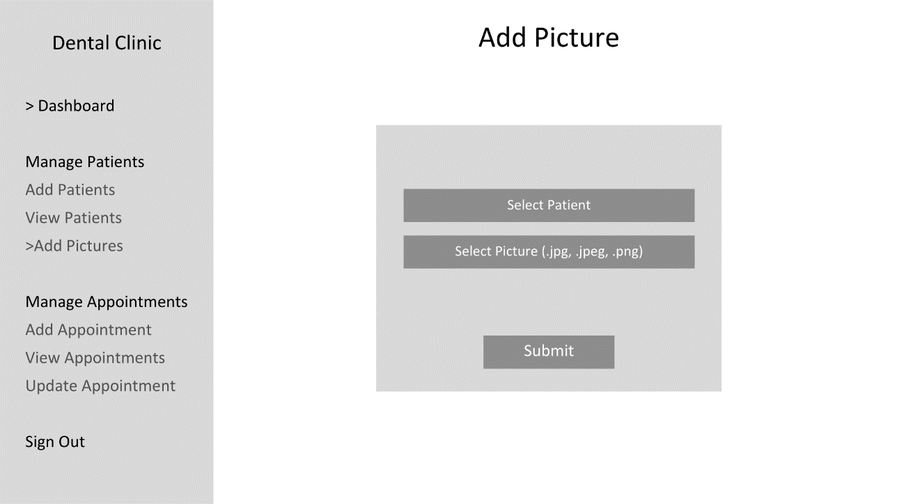

View Patients page

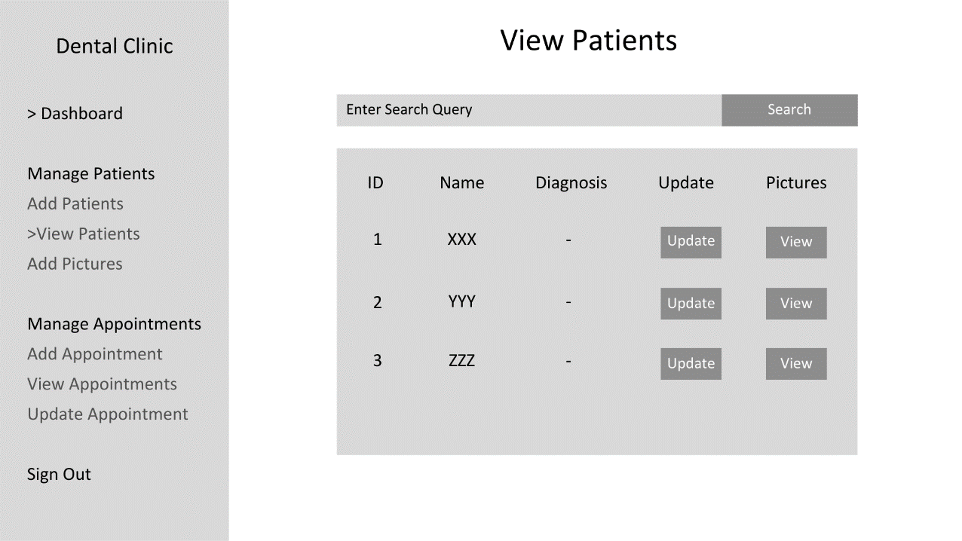

Update Patient Diagnosis page

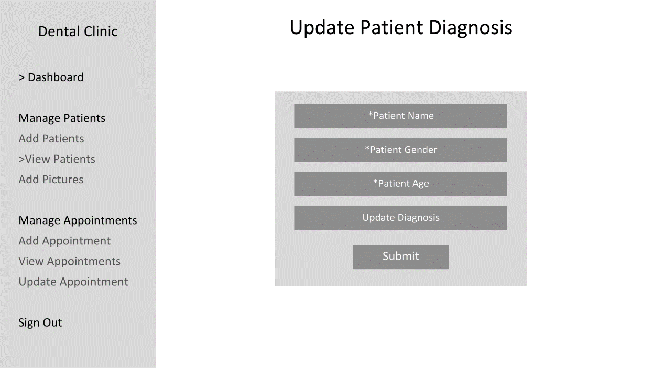

View Pictures page

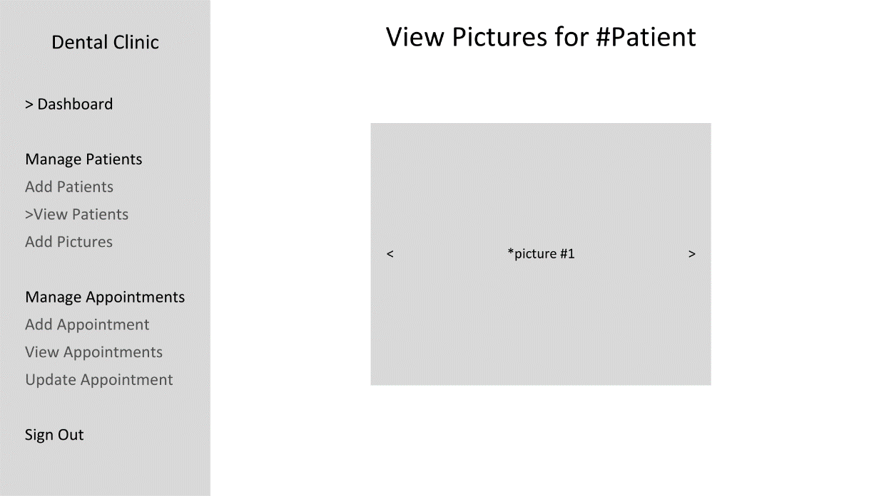

Add Appointment page

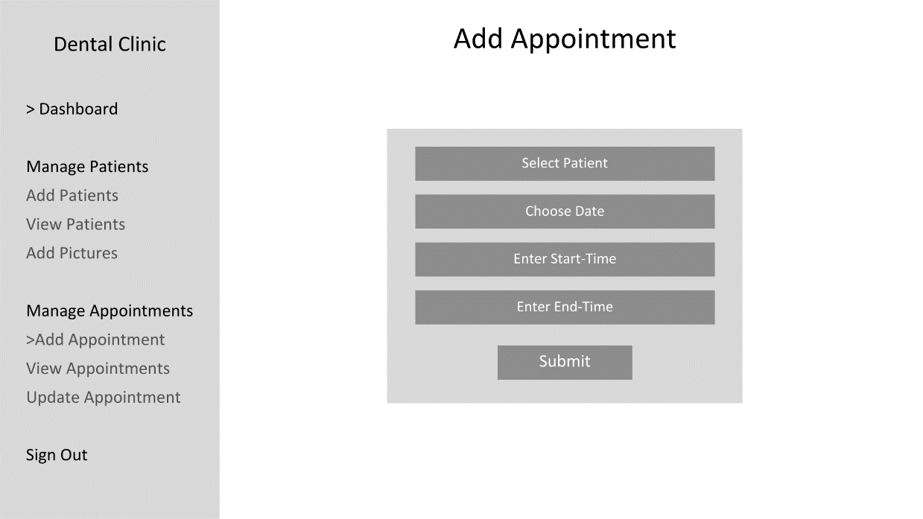

View Appointments page

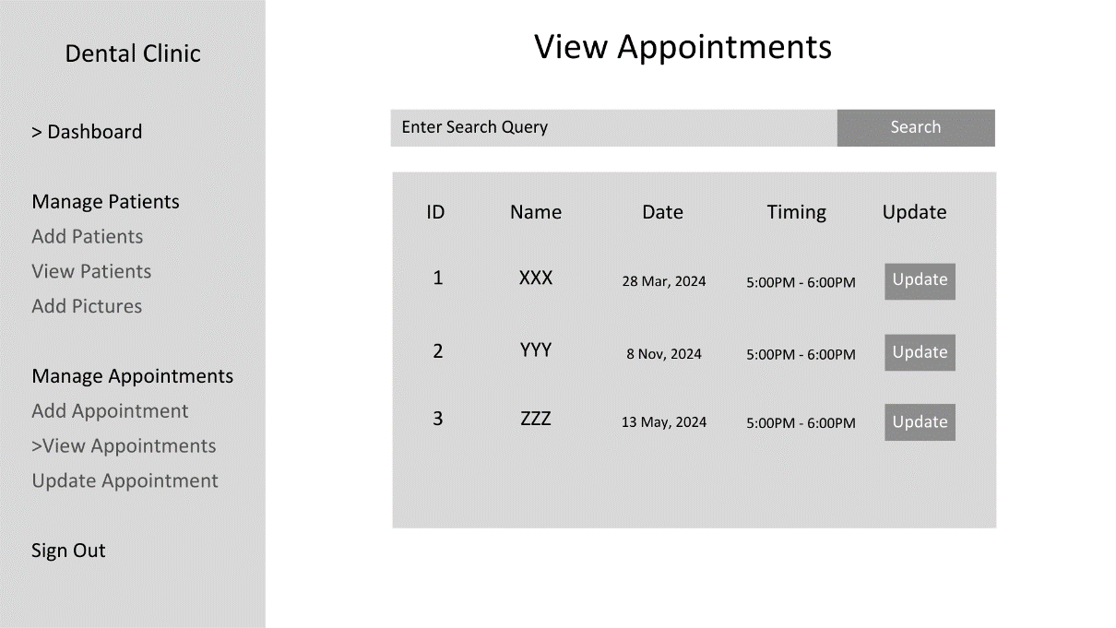

Update Appointment page

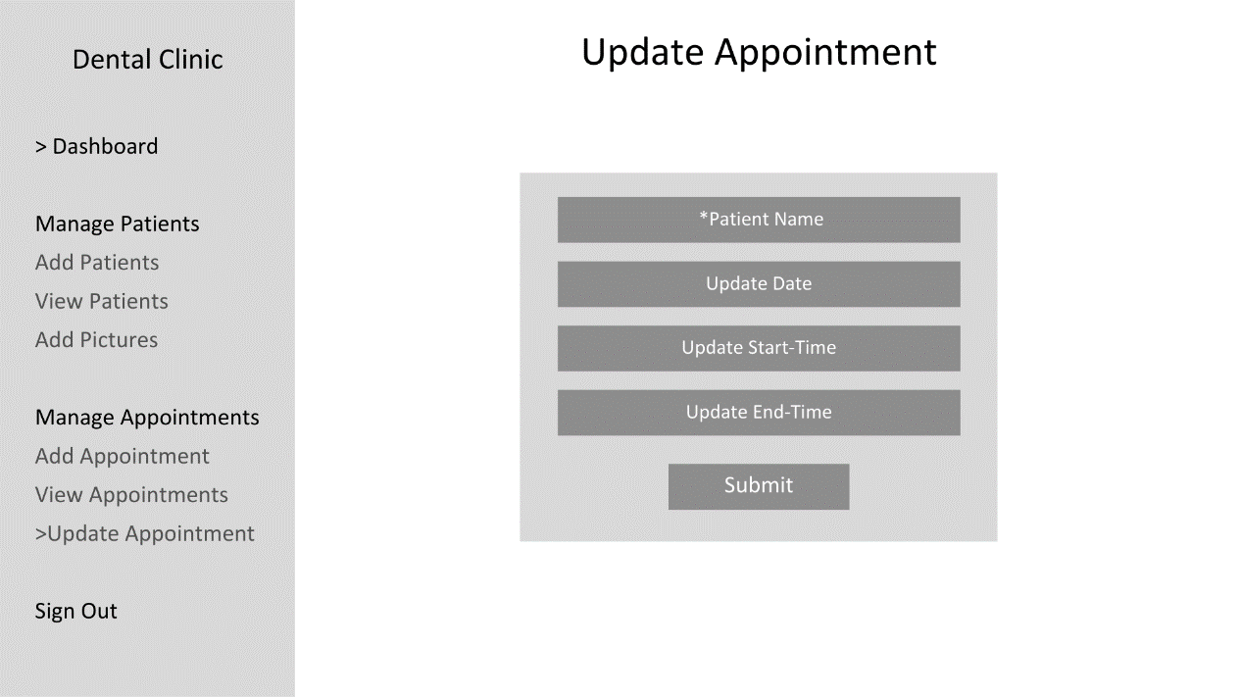

**Testing plan**

|  |  |  |  |
| --- | --- | --- | --- |
| Feature | Action | Expected Outcome | Success Criteria |
| Signup/Signin | Create a user and/or signin. | Creating a user and signing in is allowed. | 1 |
| OTP Authentication | Email OTP to user and check if OTP entered is correct. | Signup is only allowed when email is validated through OTP | 2 |
| Add patients | Enter new patient details into database. | The application registers the patient into the database with the corresponding details. | 3 |
| Display patients | Show the list of added patients and their ID, Diagnosis, and button to view pictures. | All the patients are accurately listed in the view patients page and the buttons redirect to the correct pages. | 4 |
| Search patients | Filter patients based on name, gender, or age. | The application should correctly filter patients. | 5 |
| Add diagnosis | Add additional diagnosis information for patients. | The application should display the diagnosis for the corresponding patient when added. | 6 |
| Upload pictures | Upload pictures into the database. | Pictures uploaded must be registered with the corresponding patient details into the database. | 7 |
| View pictures | Show the pictures uploaded for the corresponding patient. | All the uploaded pictures for the corresponding patient must be displayed as a carousel. | 8 |
| Add/remove appointments | Add or cancel appointments for patients. | The application must allow the appointment details to be registered into the database and deleted from the database. | 9 |
| Update appointments | Update appointment timings. | The application must allow the appointment timings to be updates in the database. | 10 |
| Unique appointments | Check for overlap in appointment timings. | An appointment is only created if it does not overlap with the timings of any other existing appointments. | 11 |
| Display grand total | Display number of patients and appointments. | The total number of patients and appointments should be displayed on the dashboard. | 12 |
| Display appointments | Show current day appointments. | The appointments for that day should be displayed on the dashboard. | 13 |